**EXPERIMENT-19**

Install a C compiler in the virtual machine created using virtual box / VM Ware Workstation / Player and execute Simple C Programs.

**Implementation:**

**Step-1:**

Open VMware and select “Create a new virtual Machine”

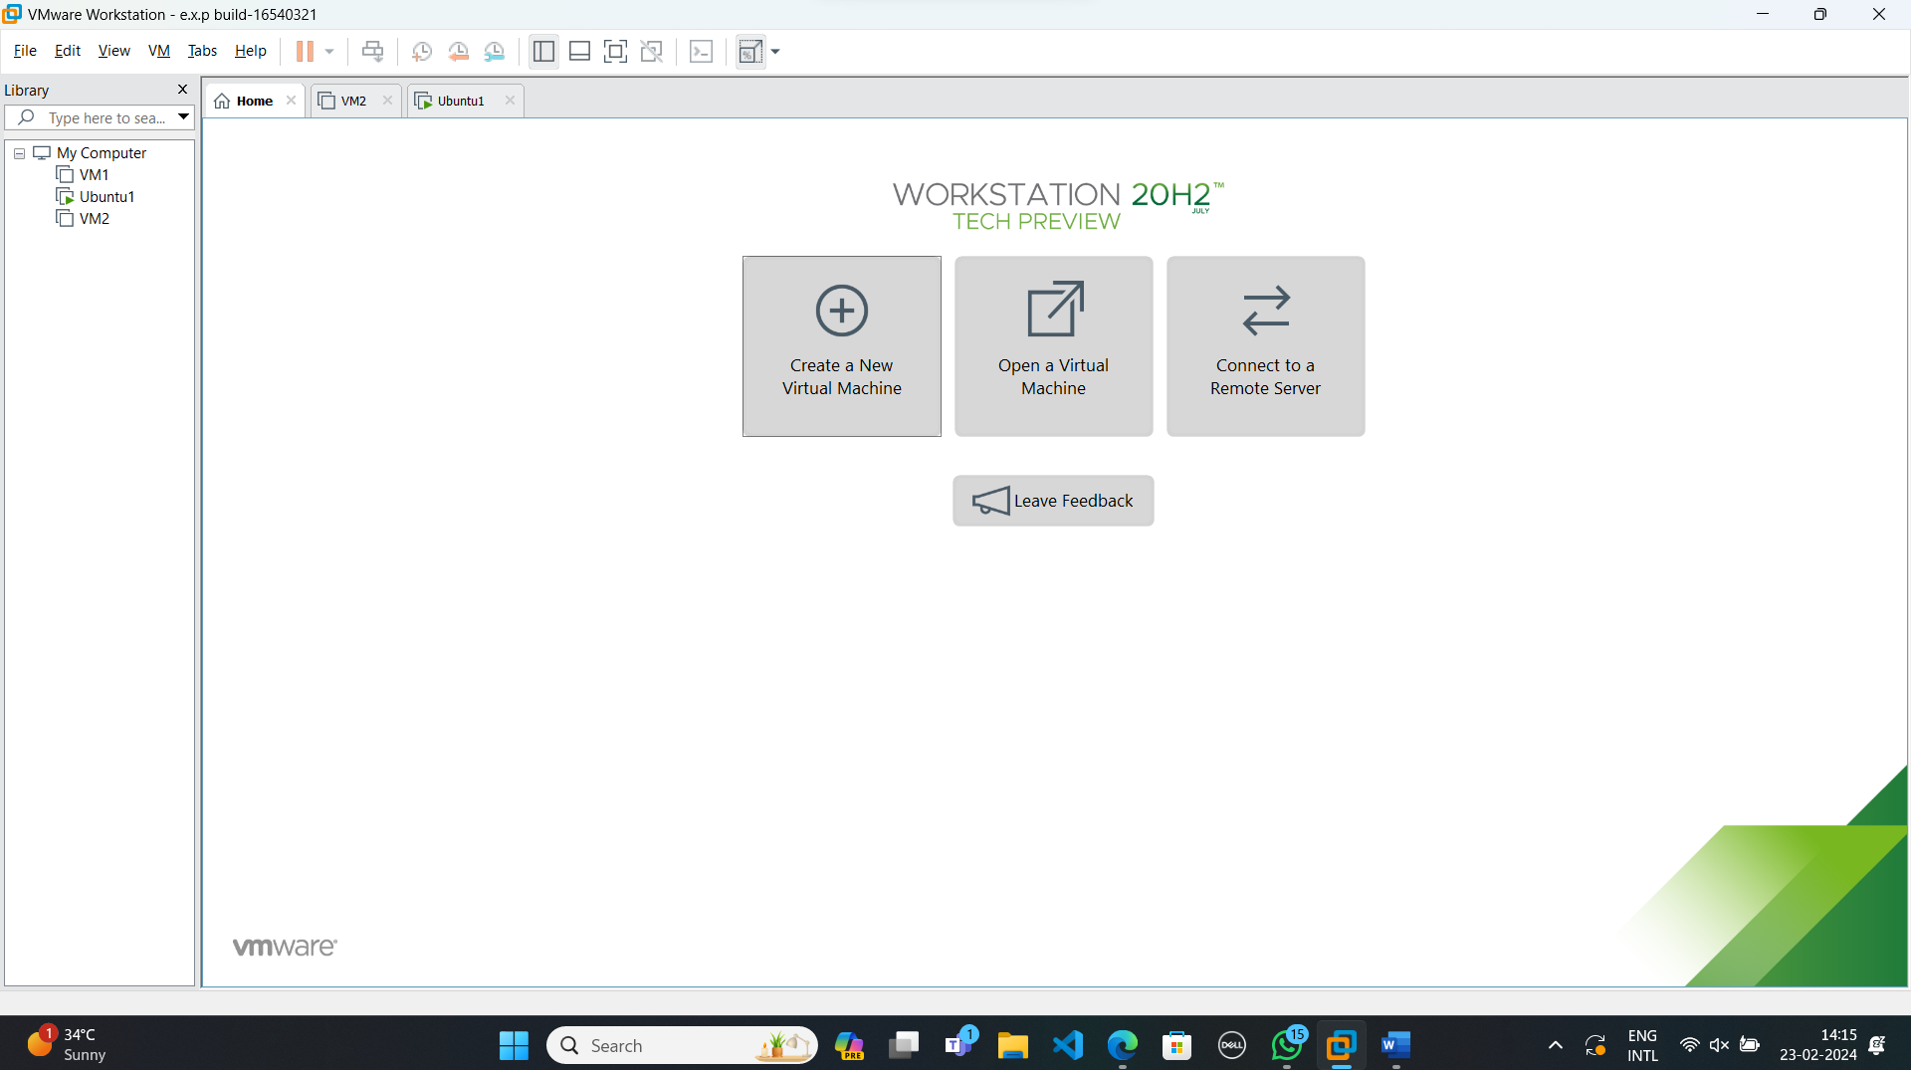

**Step-2:**

Do the basic configuration settings.

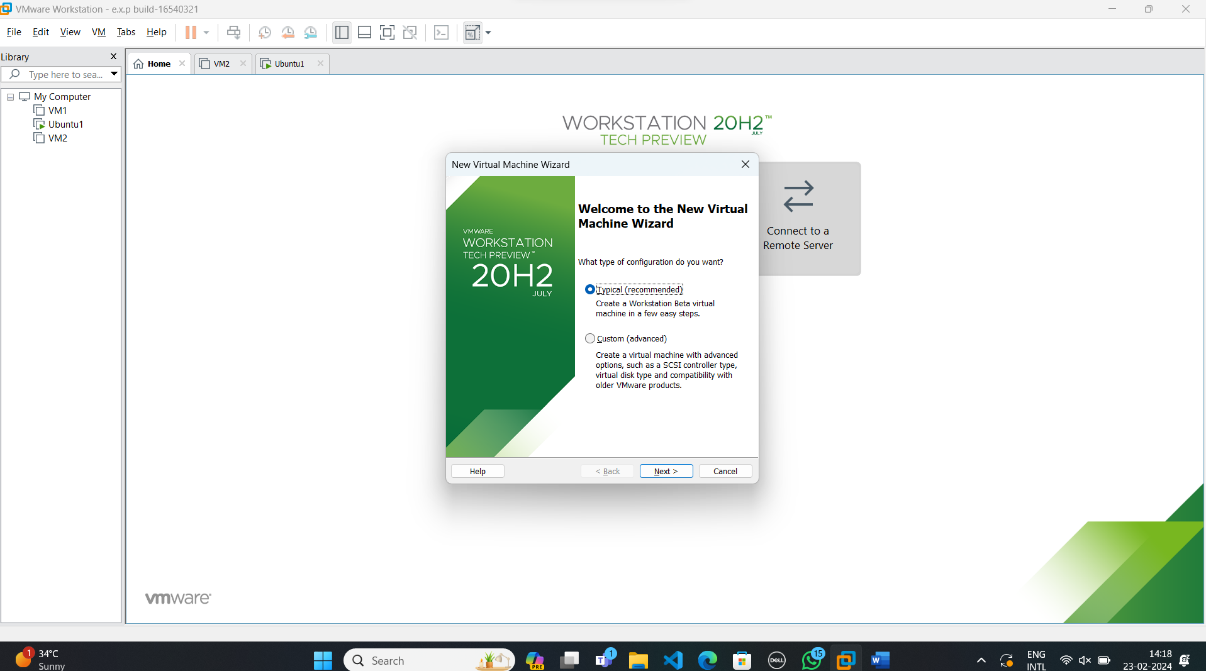

**Step-3:**

Select disk image file option and load the OS file.

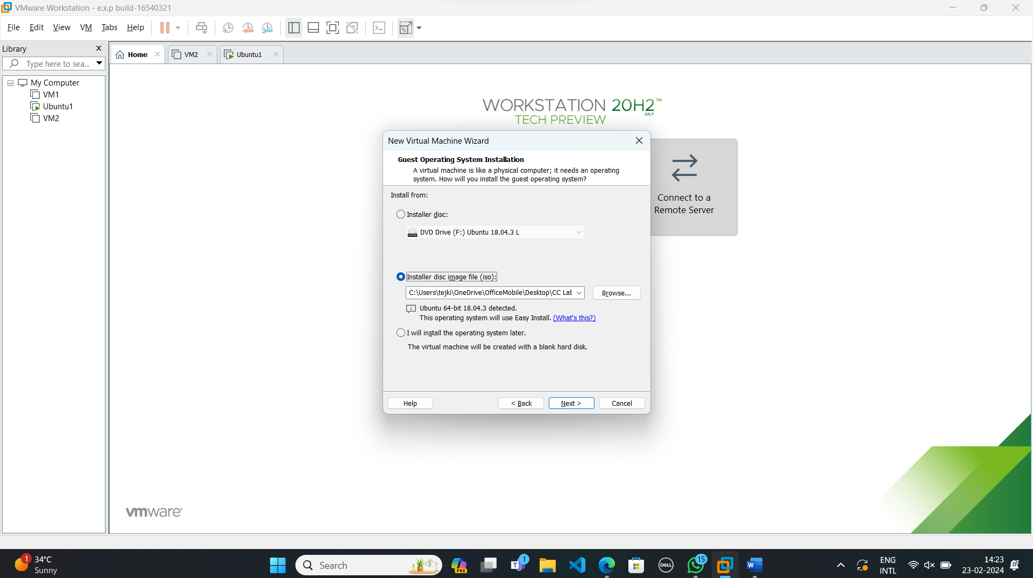

**Step-4:**

Create new user name and password.

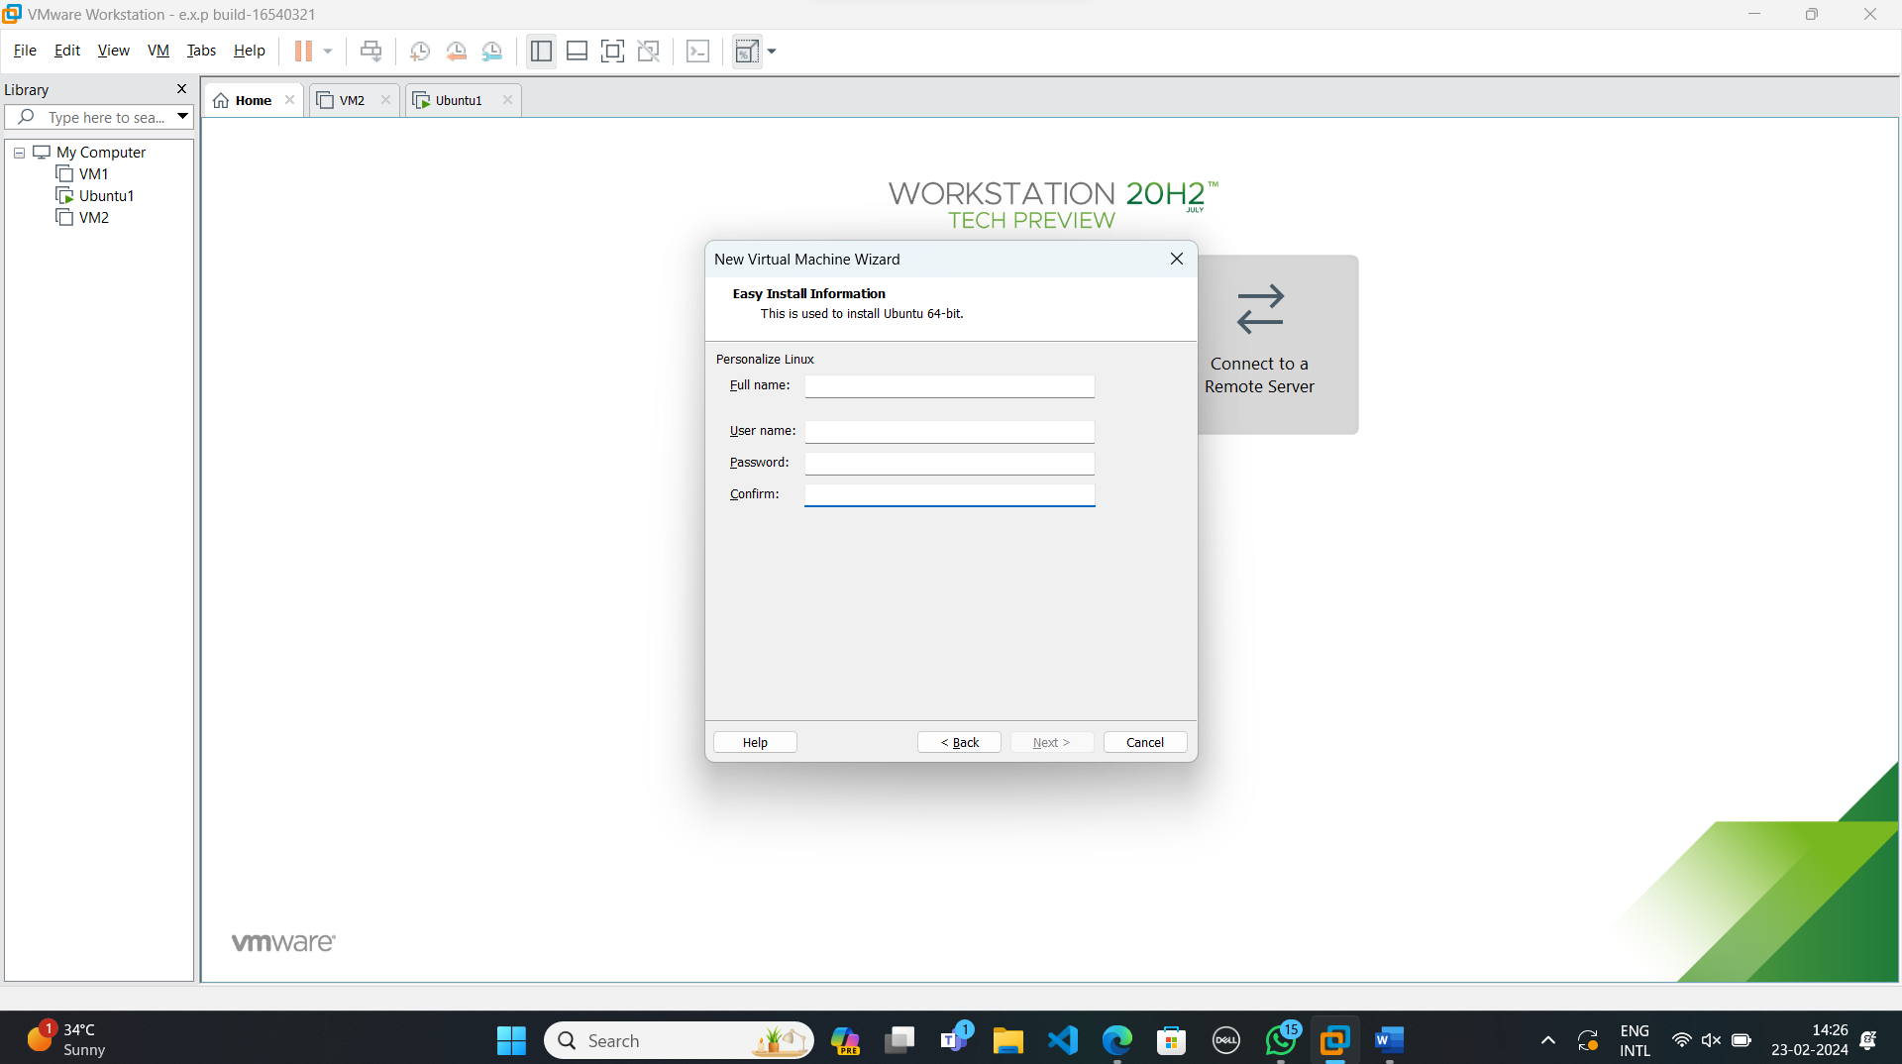

**Step-5:**

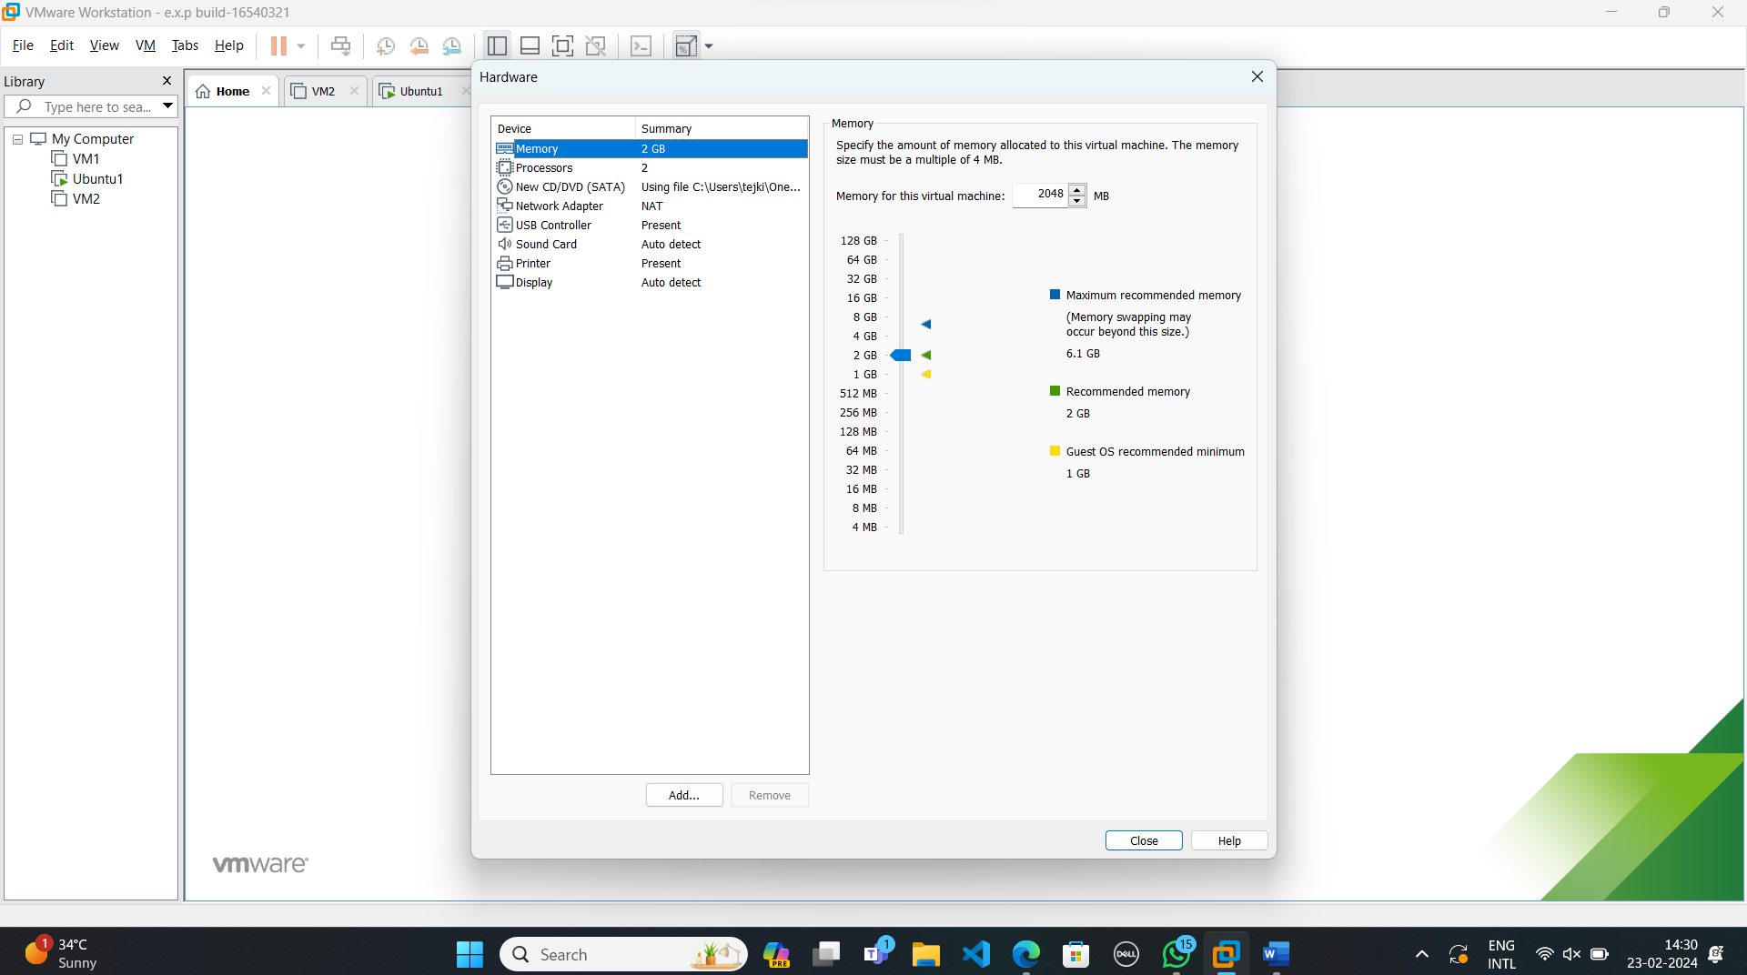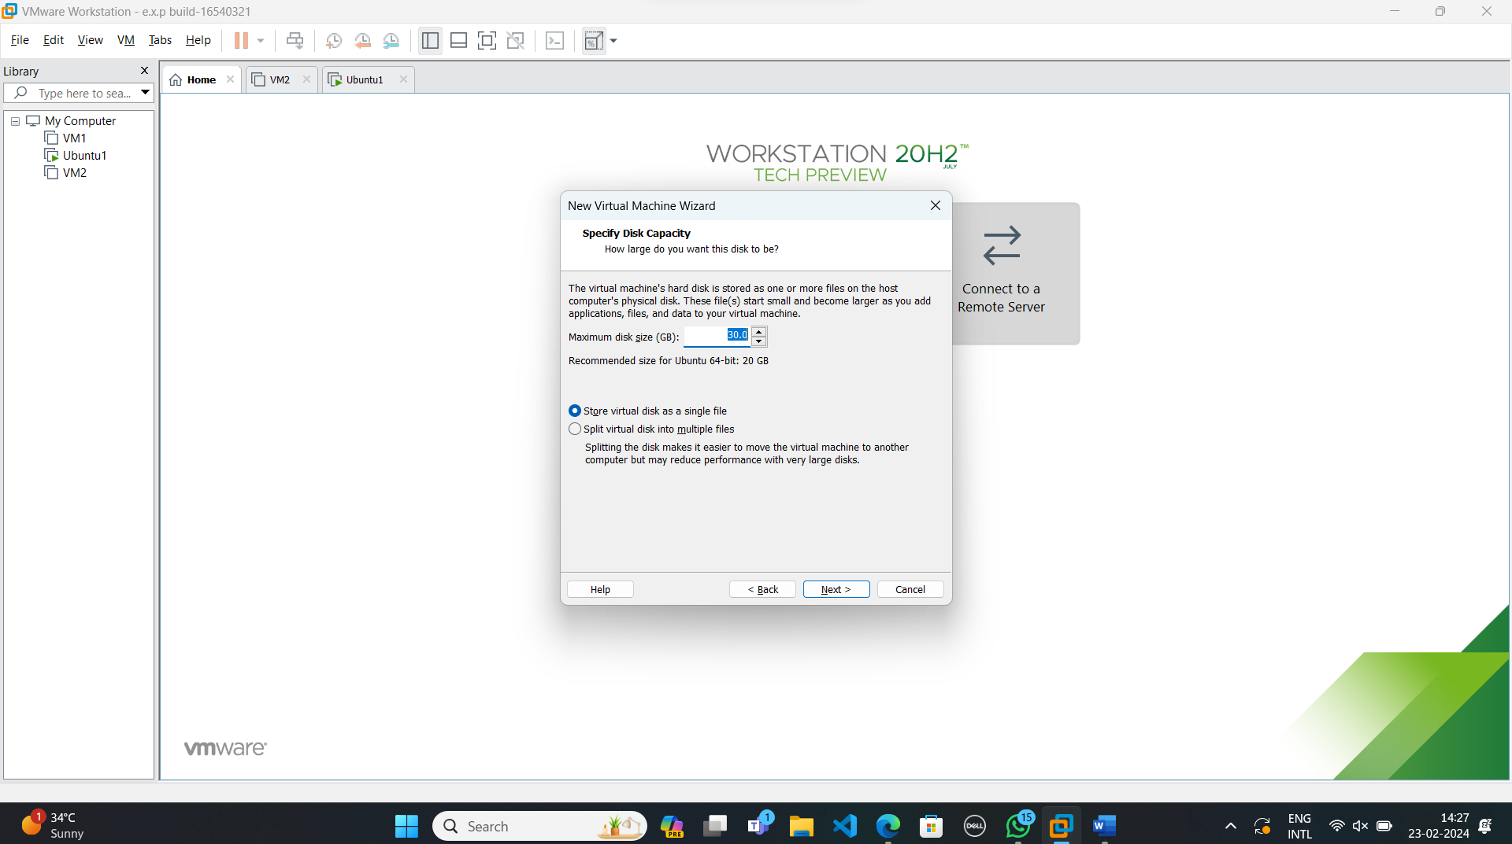

**Step-6:**

Launch the Virtual Machine.

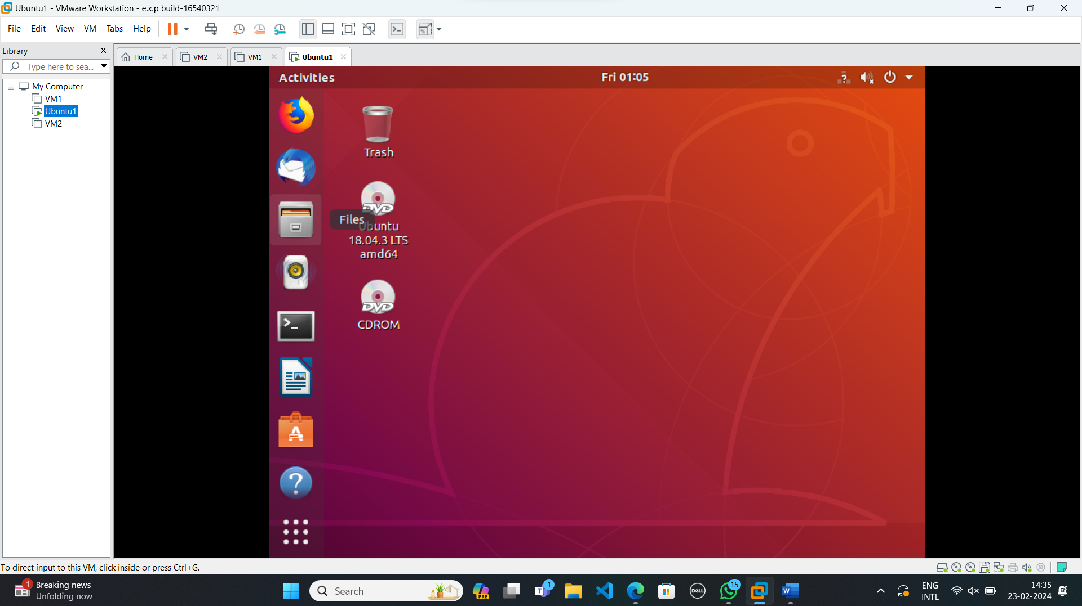

**Step-7:**

Open terminal and type “sudo apt install gcc” and execute the command.

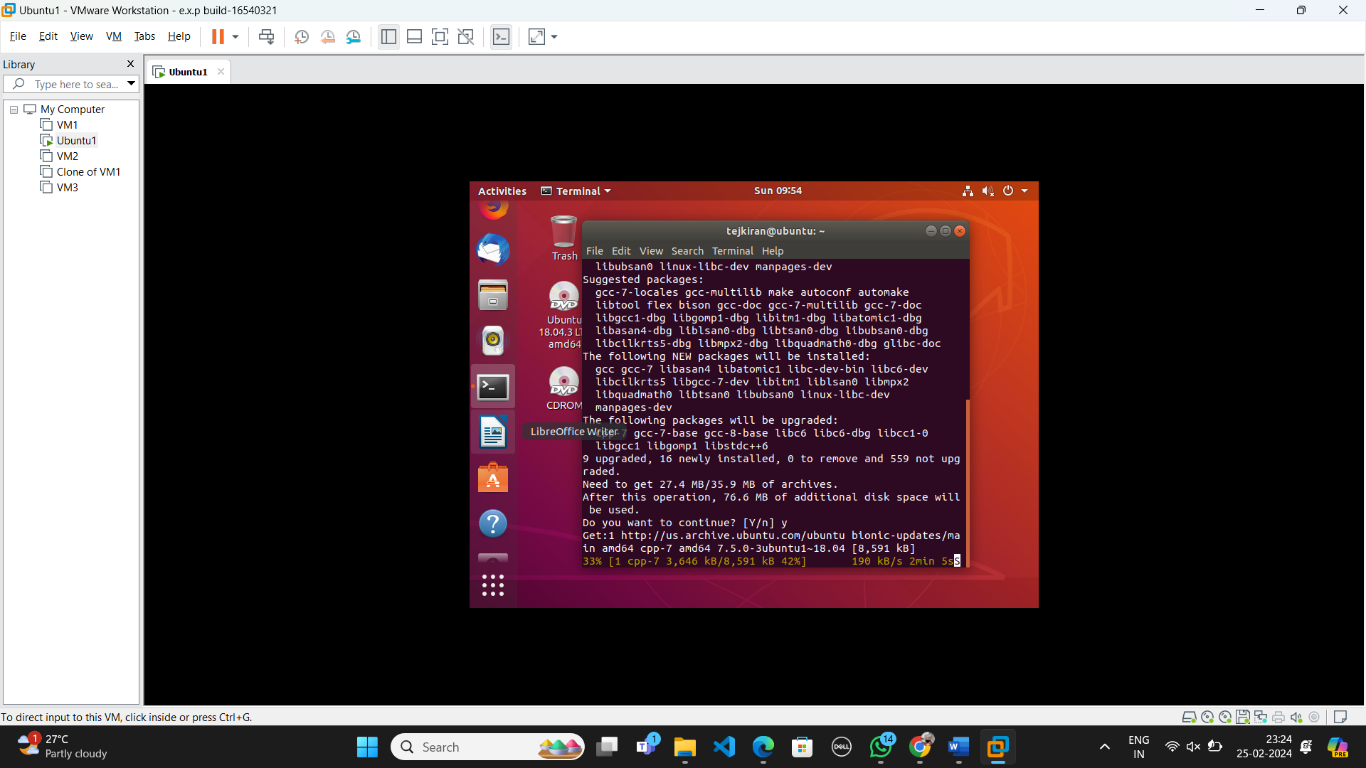

Step-8:

Check the version of gcc type”gcc --version”.

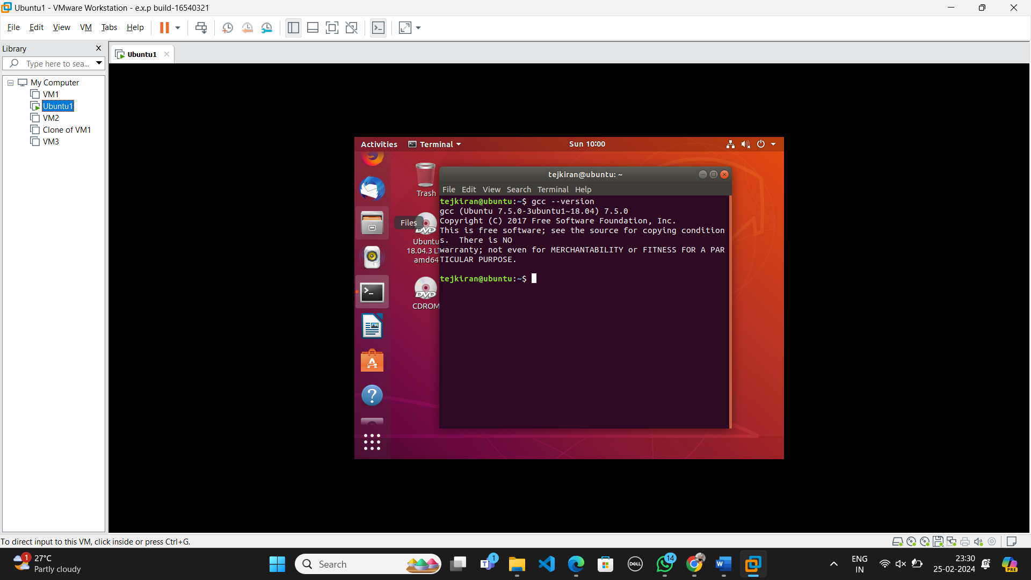

Step-9:

In desktop of ubuntu create one text document and write some simple c program then save it as

“Filename.c”

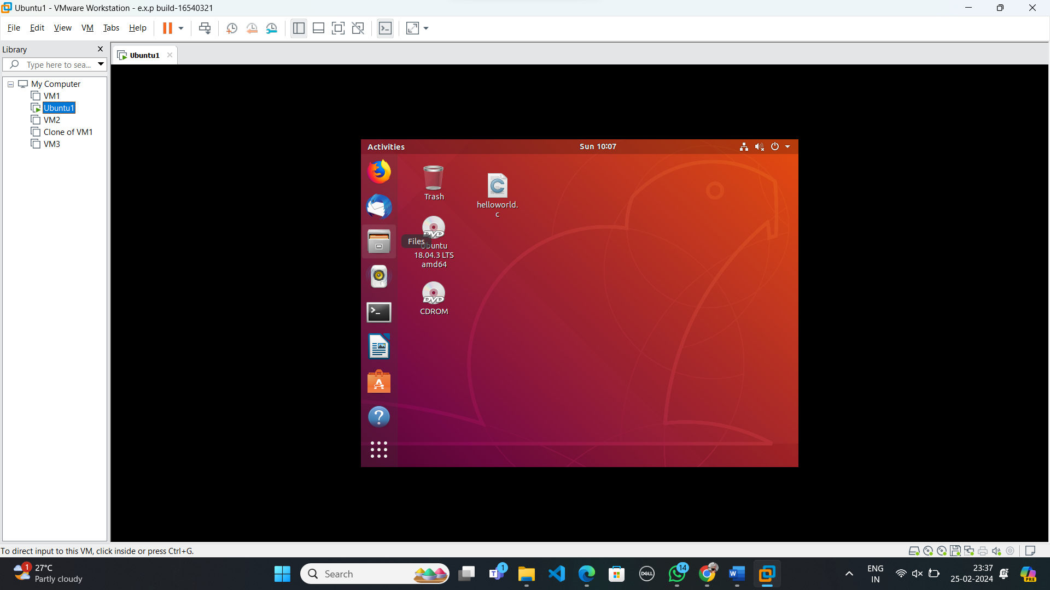

Step-10:

Change directory to desktop in terminal.

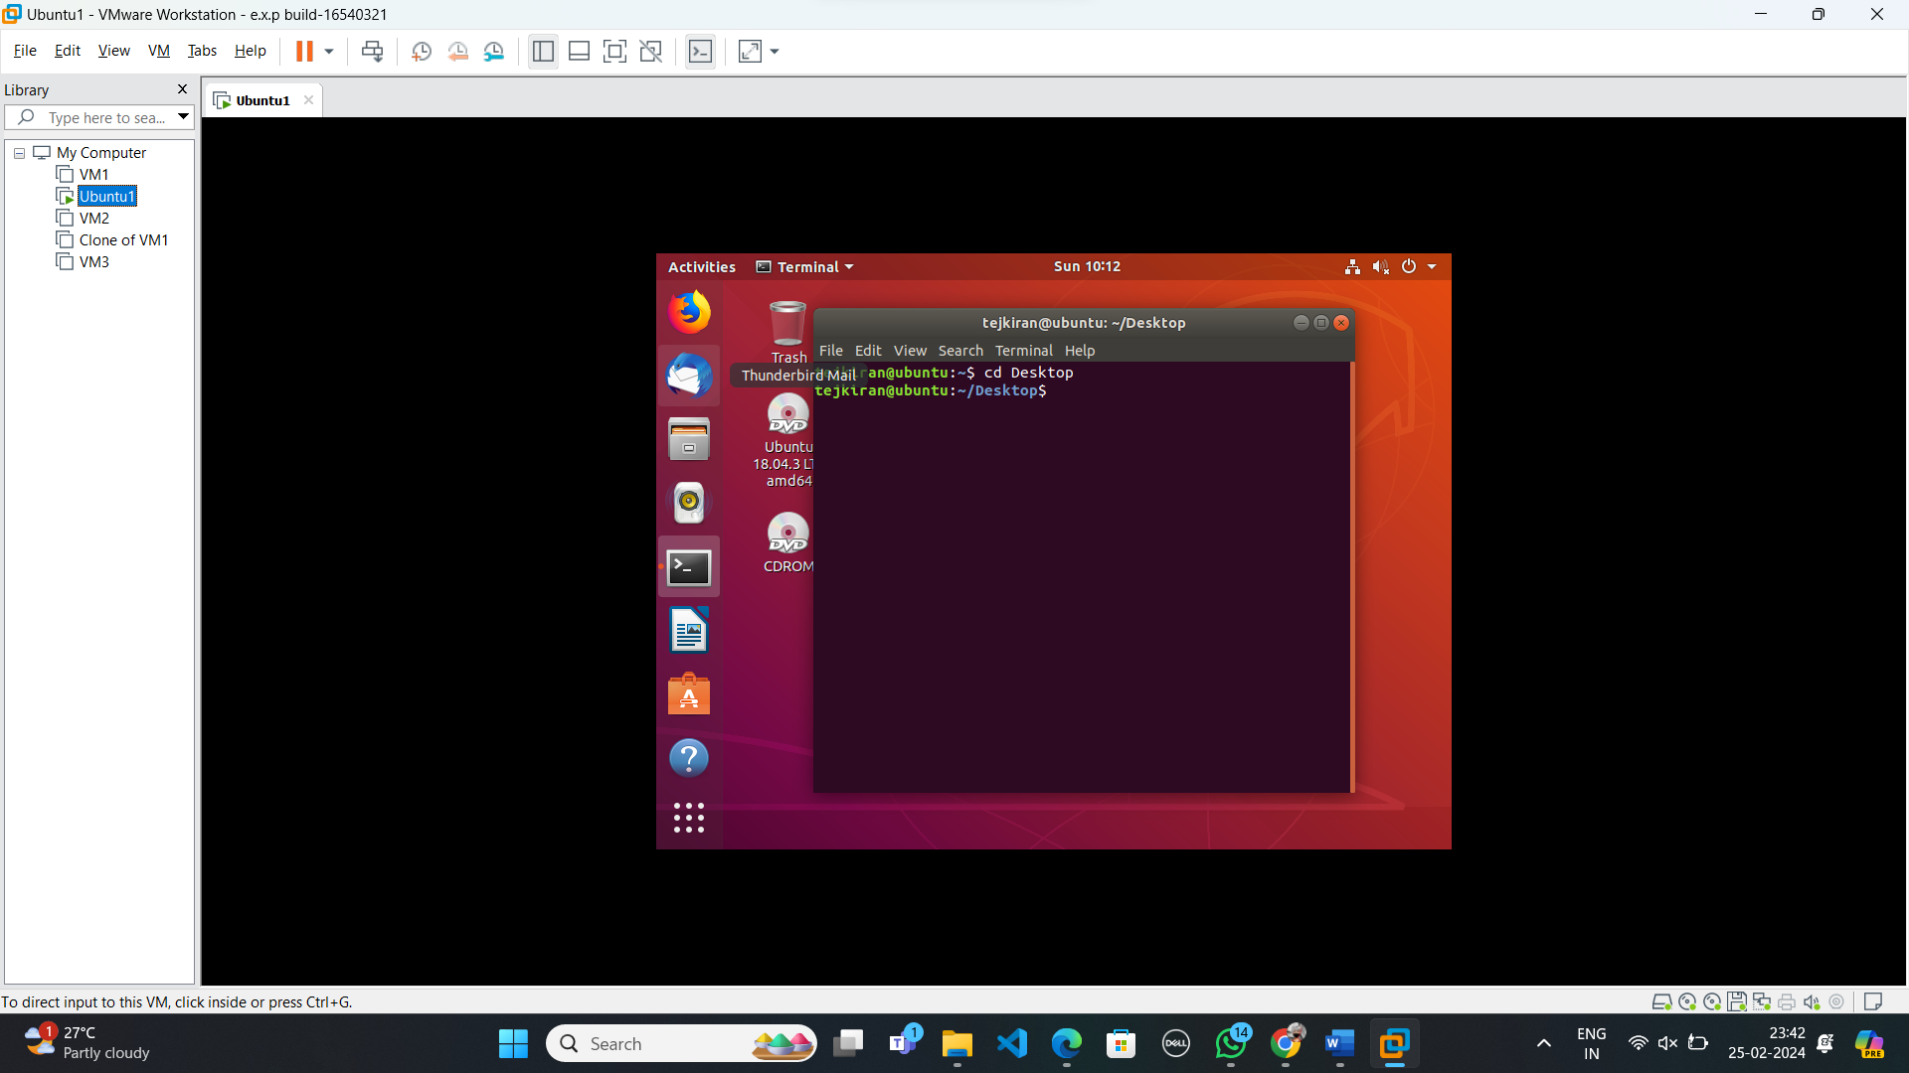

Step-11:

Compile and run the c program with the following commands in terminal.

gcc filename.c

./a.out

